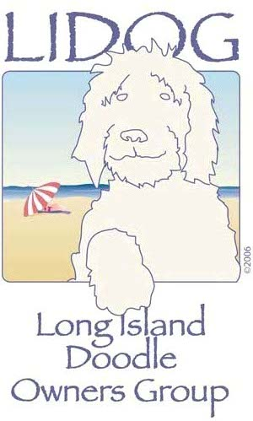

It’s time for another romp! April 18, 2015. We are looking forward to another great day together! Following our past year theme we are holding another "ROMP AROUND THE WORLD" in coordination with The International Doodle Owners Group, Inc. (IDOG). After expenses are covered, the remaining money will be donated to IDOG.
Just as in previous years the romp will be held at our regular Long Island indoor venue. Although renting the facility is required, it is nice not to have to worry about the weather. Cold drinks and snacks will be served for the humans. Cost of the food is included in your entrance fee. As in the past, you can save a little by sending in your payment ahead of time rather than paying at the door.
LOCATION: Community Church of Syosset
Gymnasium (Rubber floor)
36 Church Street
Syosset, New York 11791
WHEN: April 18, 2015
TIME: 11:00 - 3:00
Fee:

Doodle & Their Family Individuals without a dog
$20.00 Paid in Advance (prior to 4/04/15) $4.00 Per Person Paid in Advance (before 4/04/15)
$25.00 Paid at the Door $5.00 Per Person - Paid at the Door
If you would like to prepay, please fill out the waiver on my “romp” page and send it back to me with your payment payable to:
Pat Lovell
P.O. Box 161
Syosset, New York 11791
Returning the waiver will allow us to have a name tag made for you and save time at the door.

Pat Lovell, Long Island IDOG Community Liaison
Gold Coast Labradoodles
Goldcoastlabradoodles.com
Goldcoastdoodle@optonline.net
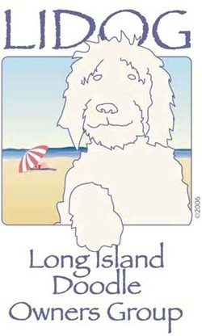

Romp Waiver and Release – April 18, 2015

Name(s) _____________________________________________

_____________________________________________

_____________________________________________

_____________________________________________

Address _____________________________________________

Phone _____________________________________________

Email _____________________________________________

Dog name(s) _____________________________________________

_____________________________________________

I understand that I am solely responsible for the health of my dog(s) and that they are up-to-date on vaccinations. Any medical issues that arise from our participation, is my responsibility.

I understand that I am solely responsible for any harm caused to or by my dog(s) and family members while my dog(s) is/are on the demised premise, Community Church of Syosset.

I hereby release and agree to hold harmless Pat Lovell, Community Church of Syosset, it's owners, members, employees, agents and the International Doodle Owners Group, Inc. and their representatives, from any and all liability, claims, suits, or damage of any nature or kind, or for any liability, claims, suits, actions, loss, injury or damage which I, my family or my dog(s) may sustain or which may be caused in any way by my dog(s). I specifically, without limitation, agree to fully indemnify Community Church of Syosset and the International Doodle Owners Group, Inc. and their representatives, Pat Lovell for any and all such liability, claims, suits, actions, losses, injury or damage.

I certify that I have made full disclosure and have read, understand and accept the terms, conditions and statements in this agreement. Furthermore, I acknowledge that this agreement shall be effect and binding upon all members of my family and or party.

Signature: ___________________________ Date: _____________________________

